投標注意事項:
Bidding Documents Submission Notice:

- 請將所有投標文件備妥並密封於信封內。
Please make sure you have all bidding documents ready, and make sure your tender is in a sealed envelope.
- 請將外標封黏在快遞信封外如圖示。
Please paste our cover sheet on the outside of a forwarder’s envelope as below.
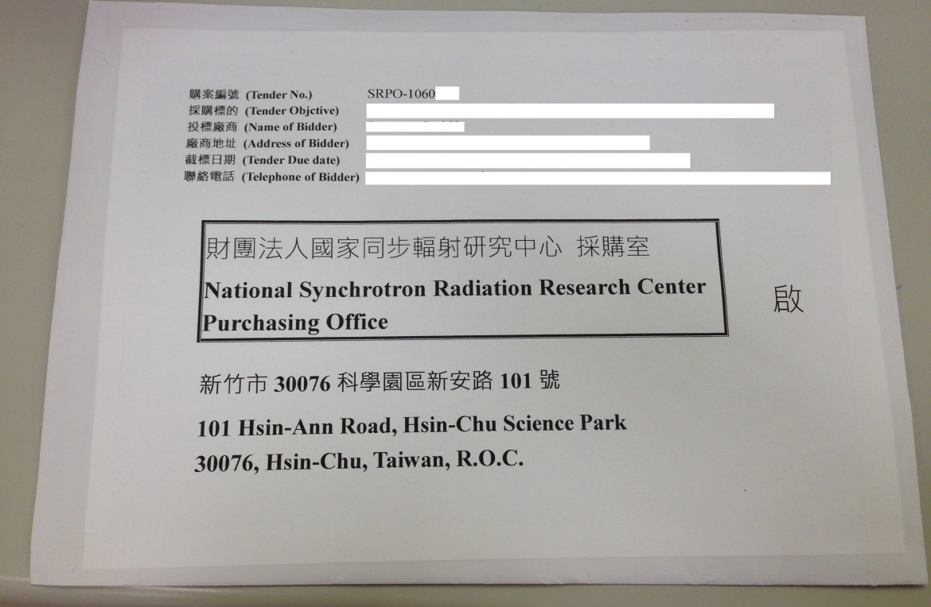
- 本案須檢附以下投標文件:
This required bidding document includes:
■設立登記證明
A Certificate of registration or establishment documents of under applicable law in your country
■用印之標價清單
A signed Price List of Tender with your Bid Price
■投標廠商代理人授權書
Power of Attorney signed by Company President or CEO
■企劃書3份
Proposal in three complete sets, the following items shall be included in your proposal:
審 查 項 目 (Examination Item) | 項 目 說 明  (Description) | 配分(Score)
廠商信譽、履約能力及實績  (Tenderer’s reputation, performance capability and its achievement) | 1.提供曾完成與本案類似之承做經驗與實績(Providing tenderer’s contract performance record or similar experience and achievement example)  2.廠商在全球或在台銷售業績與服務狀況(Tenderer’s sale outstanding accomplishment and its after-sales services description) | 30 分
技術規格性能  (Tenderer’s technical specifications, performance) | 1.產品設備內容（含軟、硬體架構或配置、主要配備內容及廠牌名稱）(Tenderer’s product description including its software, hardware structure, allocation, main equipment and manufacture brand)  2.產品未來相容、擴充能力，與既有環境及設備之整合情形(Providing product its compatible and expandable capability and how to integrate with current environment and original equipment) | 30 分
履約品質及管理執行能力(Tenderer’s performance quality and its management capability) | 1工作項目劃分品質內容與保證措施、交付項目與測試時程等規劃(Examine tenderer’s mark off action items and its evaluate quality control description, delivery items and inspection planning)  2.國內外支援體系與技術能力支援說明(International and local technical logistic support description)  ※請留意交期不得晚於契約規範之交期  ※Please note that a bidder should accept NSRRC required schedule, or offer an earlier delivery schedule. | 20 分
價格(Price) | 價格明細及分析(Price list and Cost breakdown) | 20 分
- 請於截標前將投標文件送達本中心。
Please submit your documents to NSRRC by closing deadline.

※ 請留意投標文件逾期將不予受理。
Please note a late tender will not be considered.

Kind regards,
Ms. Kate Hsu
Deputy Administrator/Procurement Office
Tel:+886-3-5780281 ext:8406
E-mail address: hsu.tw@nsrrc.org.tw

